Reroductive System – Self-Directed Unit
Task #3

Biology 12
Name:
Fertilization to Birth
Outcome 23: I can explain the events leading up to and including human conception.
Outcome 24: I can explain the developmental events from zygote to fetus in humans.
Outcome 25: I can explain the process of human birth including the hormones involved.

Directions: Complete the following questions using your textbook (Prentice Hall) on pages 1016 and 1017 as well as the Nelson textbook on pages 522 to 525 to assist you. Remember this material will be handed in with your extension portfolio.

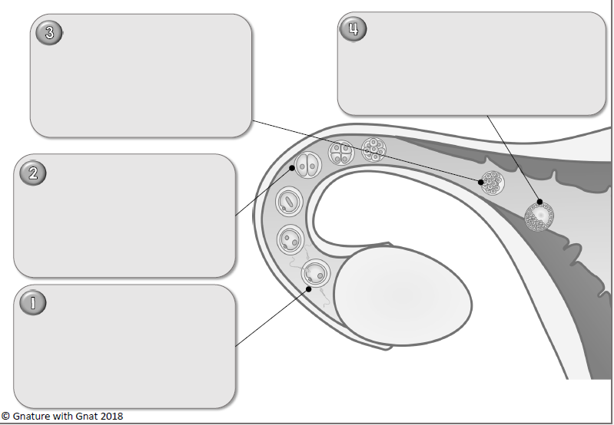
- Using the diagram below, state what is occurring at each stage from fertilization to blastula.

Morula
Blastula

Travel

Fertilization

- Explain what occurs when the sperm reaches the egg. How is it that only one sperm enters the egg?

- How does the zygote become implanted within the uterus wall and when does this occur? What does the zygote do once it is implanted?

- The menstrual cycle is suppressed during pregnancy, explain why this is important and what causes it to occur.

- What are the 3 membranes that are found in and around the developing fetus? What are each of their jobs?

- Briefly describe what happens in each of the 3 trimesters of fetal development, indicate what weeks of the 40-week gestational period each trimester occurs during.

- What initiates birth and what steps does a woman go through to give birth to a baby?

- Explain the roles of the following hormones: relaxin, oxytocin and prolactin during and after child birth.

