Extension Questions: Further Understanding Photosynthesis
Name: Biology 11
Understanding Photosynthesis – Page 204 & 206 will help in the textbook.
- The understanding of photosynthesis has occurred over many years and has had contributions from multiple scientists. On a separate piece of paper, create a timeline indicating the scientists that contributed to the development of the understanding of photosynthesis as well as what they did to contribute.

Light & Pigments – Page 207 will help in the textbook
- We discussed that photosynthesis requires the use of water, CO2 as well as light; however we did not talk about what is involved with the light. Explain how a plant gathers light by explaining the chemical found within chloroplast that allows for this to happen and indicating the main types this chemical is found as.

- Describe the relationship between chlorophyll and the color of plants (why are the leaves green in colour)?

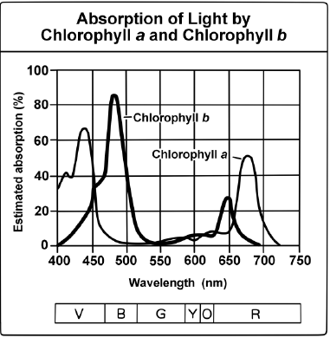
- Using the chart to the right titled “Absorption of Light by Chlorophyll” answer the following questions:
- What light(s) is/are best absorbed by plants?

- How well would a plant grow under pure yellow light? Explain your answer.

Rate of Photosynthesis

- State three factors that affect the rate at which photosynthesis occurs. (see page 214 of the textbook)

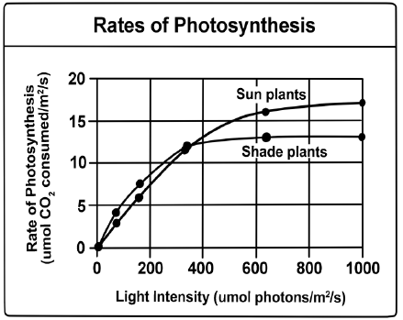
- The rate at which a plant carries out photosynthesis depends in part on its environment. Plants that grow in the shade, for example, carry out photosynthesis at low levels of light. Plants that grow in the sun, such as desert plants, typically carry out photosynthesis at much higher levels of light. The graph compares to the right compares the rates of photosynthesis between plants that grow in the shade and plants that grow in the sun. It shows how the rate of photosynthesis changes with the number of micromoles of photons per square meter per second (µmol photons/m²/s), a standard unit of light intensity. Answer the following questions using the graph provided.

- When light intensity is below 200 µmol photons/m²/s, do sun plants or shade plants have a higher rate of photosynthesis?

- Does the relationship in question 1 change when light intensity increases above 400 µmol photons/m²/s? Explain your answer.

- Suppose you transplant a sun plant to a shaded forest floor that receives about 100 µmol photons/m²/s. Do you think this plant will grow and thrive? Why or why not? Use the graph to explain.

