Extension: Identifying & Making Pedigree Charts
Biology 12 Name: _____________
Directions: Watch the tutorial video showing how we identify if pedigree charts are autosomal or sex linked and dominant or recessive. When you have watched the tutorial identify each of the following.
- Is the following pedigree chart autosomal or x-linked? Dominant or recessive? Justify your answer.

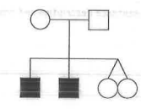

- Is the following pedigree chart autosomal or x-linked? Dominant or recessive? Justify your answer.
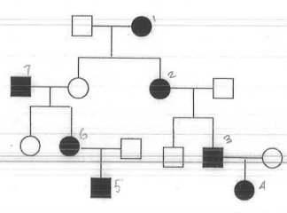

- Is the following pedigree chart autosomal or x-linked? Dominant or recessive? Justify your answer.
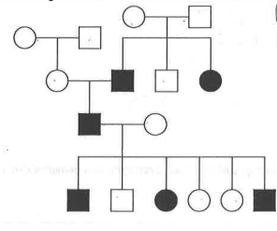

- Create a pedigree chart of the families indicated below that have muscular dystrophy running through them. Muscular dystrophy can be inherited in multiple ways so each family’s situation may be different.
Please note that carriers are coloured in grey!
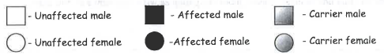
Key:

Family #1: Chad and Veronica got married and had Brittany, Kristin and Harry. It was discovered that Harry had muscular dystrophy. Brittany married Larry and had Stephan and Stephanie. Stephan also had muscular dystrophy. Larry’s brother Barry also had muscular dystrophy but neither of their parents had the disorder.
Draw a pedigree chart to show the above situation:

Is this an autosomal or x-linked disorder?
Dominant or recessive?
Justify your answer.

Family #2: Debbie married David and had three children, Darren, Dawn, and Derek. David, Darren, and Derek all discovered they have muscular dystrophy. Derek met Didi and had two children, Denise and Destiny. Denise also has muscular dystrophy and is partners with Dirk. They had two children, Dee and Devan. Dee has muscular dystrophy.
Draw a pedigree chart to show the above situation:

Is this an autosomal or x-linked disorder?
Dominant or recessive?
Justify your answer.

