Extension: Cell Membrane
Case Study – What is the Relationship between the Cell Membrane and Cystic Fibrosis?
Names: _________________________________________ Biology 11
Part I: What is cystic fibrosis?
Dr. Weyland examined a six month old infant that had been admitted to University Hospital earlier in the day. The baby's parents had brought young Zoey to the emergency room because she had been suffering from a chronic cough. In addition, they said that Zoey sometimes would "wheeze" a lot more than they thought was normal for a child with a cold. Upon arriving at the emergency room, the attending pediatrician noted that salt crystals were present on Zoey's skin and called Dr. Weyland, a pediatric pulmonologist. Dr. Weyland suspects that baby Zoey may be suffering from cystic fibrosis.

CF affects 1 in every 3,600 children born in Canada and more than 4,100 Canadian children, adolescents and adults with cystic fibrosis attend specialized CF clinics. It disrupts the normal function of epithelial cells — cells that make up the sweat glands in the skin and that also line passageways inside the lungs, pancreas, and digestive and reproductive systems.

The inherited CF gene directs the body's epithelial cells to produce a defective form of a protein called CFTR (or cystic fibrosis transmembrane conductance regulator) found in cells that line the lungs, digestive tract, sweat glands, and genitourinary system.

When the CFTR protein is defective, epithelial cells can't regulate the way that chloride ions pass across cell membranes. This disrupts the balance of salt and water needed to maintain a normal thin coating of mucus inside the lungs and other passageways. The mucus becomes thick, sticky, and hard to move, and can result in infections from bacterial colonization.

- Cystic Fibrosis (CF): What is it? How do you “get” CF? Is there a cure? How many Canadians suffer from it?

- What is CFTR and what are its effects on CF individuals?

- With what you know about equilibrium and isotonic solutions, explain why it is important to regulate the salt levels within cells.

Part II: CF is a disorder of the cell membrane
Imagine a door with key and combination locks on both sides, back and front. Now imagine trying to unlock that door blindfolded. This is the challenge faced by David Gadsby, Ph.D., who for years struggled to understand the highly intricate and unusual cystic fibrosis chloride channel – a cellular doorway for salt ions that is defective in people with cystic fibrosis.

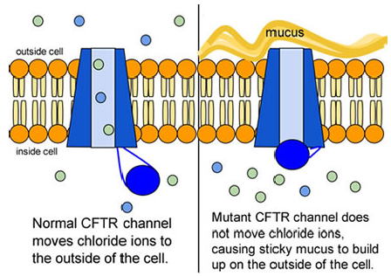
His findings, reported in a series of three recent papers in the Journal of General Physiology, detail the type and order of molecular events required to open and close the gates of the cystic fibrosis chloride channel, or as scientists call it, the cystic fibrosis transmembrane conductance regulator (CFTR).

Ultimately, the research may have medical applications, though ironically not likely for most cystic fibrosis patients. Because two-thirds of cystic fibrosis patients fail to produce the cystic fibrosis channel altogether, a cure for most is expected to result from research focused on replacing the lost channel.

- Compare the normal and the mutant CFTR protein. How would you correct the mutant protein if you had the ability to tinker with it on a molecular level?

- Why would treatment that targets the CFTR channel not be effective for 2/3 of those with cystic fibrosis?

- Sweat glands cool the body by releasing perspiration (sweat) from the lower layers of the skin onto the surface. Sodium and chloride (salt) help carry water to the skin’s surface and are then reabsorbed into the body. Why does a person with cystic fibrosis have salty tasting skin?

Part III: No cell is an island
Like people, cells need to communicate and interact with their environment to survive. One way they go about this is through pores in their outer membranes, called ion channels, which provide charged ions, such as chloride or potassium, with their own personalized cellular doorways. But, ion channels are not like open doors; instead, they are more like gateways with high security locks that are opened and closed to carefully control the passage of their respective ions.

In the case of CFTR, chloride ions travel in and out of the cell through the channel’s guarded pore as a means to control the flow of water in and out of cells. In cystic fibrosis patients, this delicate salt/water balance is disturbed, most prominently in the lungs, resulting in thick coats of mucus that eventually spur life threatening infections. Shown below are several mutations linked to CFTR:
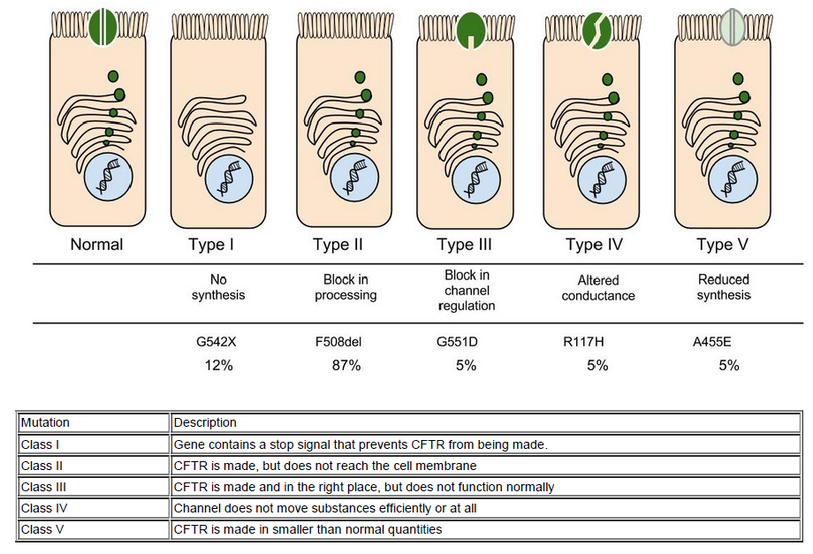

- Which mutation do you think would be easiest to correct? Justify your answer.

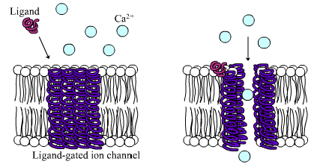
Part IV: Open Sesame
Among the numerous ion channels in cell membranes, there are two
principal types: voltagegated and ligandgated. Voltagegated
channels are triggered to open and shut their doors by changes in
the electric potential difference across the membrane. Ligandgated
channels, in contrast, require a special “key” to unlock their doors,
which usually comes in the form of a small molecule.

CFTR is a ligandgated channel, but it’s an unusual one. Its “key” is ATP,
a small molecule that plays a critical role in the storage and release of
energy within cells in the body. In addition to binding the ATP, the CFTR channel must snip a phosphate group – one of three “P’s” – off the ATP molecule to function. But when, where and how often this crucial event takes place has remained obscure.
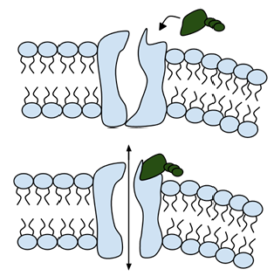
- Trace image to the right showing the ligand-gated channel for CFTR and label the structures: ligand-gated channel protein, ATP, phosphates, phospholipids.

- Summarize how the channel works.

- Consider the model of the membrane channel, what could go wrong to prevent the channel from opening?

- Where is ATP generated in the cell? How might ATP production affect the symptoms of cystic fibrosis?

Part V: Can a drug treat Zoey’s condition?
Dr. Weyland confirmed that Zoey does have cystic fibrosis and called the parents in to talk about potential treatments. “Good news, there are two experimental drugs that have shown promise in CF patients. These drugs can help Zoey clear the mucus from her lungs. Unfortunately, the drugs do not work in all cases.” The doctor gave the parents literature about the drugs and asked them to consider signing Zoey up for trials.

The Experimental Drugs

Ivacaftor ™ is a potentiator that increases CFTR channel opening time. We know from the cell culture studies that this increases chloride transport by as much as 50% from baseline and restores it closer to what we would expect to observe in wild type CFTR. Basically, the drug increases CFTR activity by unlocking the gate that allows for the normal flow of salt and fluids.

In early trials, 144 patients all of whom were age over the age of 12 were treated with 150 mg of Ivacaftor twice daily. The total length of treatment was 48 weeks. Graph A shows changes in FEV (forced expiratory volume) with individuals using the drug versus a placebo. Graph B shows concentrations of chloride in patient’s sweat.

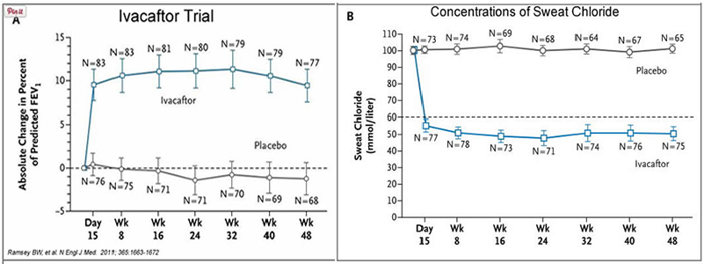

- What is FEV (if you’re not sure, look this one up)? Describe a way that a doctor could take a measurement of FEV.

- Why do you think it was important to have placebos in both of these studies?

- Take a look at the mutations that can occur in the cell membrane protein from Part III. For which mutation do you think Ivacaftor will be most effective? Justify your answer.

- Would you sign Zoey up for clinical trials based on the evidence? What concerns would a parent have before considering an experimental drug?

